EIT RawMaterials

KAVA Call 13

Lighthouse Appendix

October 2024

1. Definition and scope of Lighthouses
The EIT RawMaterials’ activities and project portfolio are developed along three guiding strategic frameworks, called Lighthouses.
1. Responsible Sourcing
2. Sustainable Materials
3. Circular Societies

Lighthouses (hereafter ‘LH’) are large-scale and long-term coordinated innovation initiatives that address critical and specific raw materials challenges for Europe. They are mission approaches to innovation and education challenges, directly steering KIC activities towards the achievement of its strategic objectives and impact KPIs. LHs will generate tangible solutions for societal challenges that have raw materials at their core. In doing so, they will raise awareness about the role and importance of raw materials and create a positive perception about raw materials and their associated industries. The LH also present the thematic framework for the KAVA Calls in terms of project topics and focus areas.
By integrating high-level innovation and education and by promoting our three approaches of responsible, sustainable, and circular raw materials value chains, EIT RawMaterials can significantly contribute to building a European industry that is strategically more autonomous, less exposed to supply chain risks, and is expanding value creation and job creation in emerging industrial sectors. These include the following value chains: batteries, fuel cells and electrolysis, magnets and motors (e.g., wind turbines and traction motors), photovoltaics, electronics (incl. digital technologies), and lightweight design (see JRC 2021; Table 1). In addition, we identified the following areas: the future of exploration, mining and processing sector; Industrial Symbiosis and 3D Printing.

The scopes, strategies and operational actions of the abovementioned LHs are summarized in Sections 3.1, 3.2 and 3.3. Additional information on the LHs and their strategic significance for the KIC can be found in the Strategic Agenda 2021-27 of EIT RawMaterials and the recently-updated EIT RawMaterials LH document.

Table 1 : The EIT RawMaterials Lighthouses drive innovation and education initiatives for every element of the value chain to secure supply, create jobs, reduce carbon emission, maximise circularity and minimise harm to our environment. Several strategic value chains are considered.
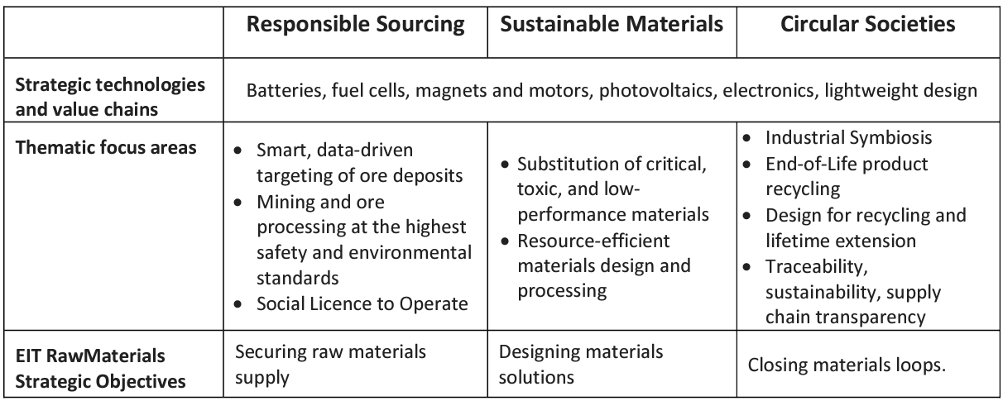

2. Critical and Strategic Raw Materials:
For a list of Critical Raw Materials, see the current 2020 EU CRM list. The term Strategic Raw Materials refers to elements used/found in technologies for the EU Green and Digital Transitions.

3. Specific topics for proposals

3.1. Lighthouse Responsible Sourcing
Challenge: Boosting European exploration and mining efforts (from greenfield to post-closure) and strengthening processing capabilities for critical strategic raw materials are vital steps toward a more sustainable future. In this context, three approaches are at the core of the Lighthouse Responsible Sourcing:

- achieving a more targeted and cost-effective exploration and quicker transition to mining operation;
- reducing the environmental footprint of mining and processing; and
- improving the efficiency of mineral and metallurgical processing.

In alignment with the above-mentioned mission, the KAVA Call 13 includes the following topics:

- Exploration: data-driven decision making in the extractive sector related to at least one of the identified, strategic EU industrial value chains
- Mining and processing: responsible sourcing of materials related to at least one of the identified, strategic EU industrial value chains
- Future exploration, mining, and processing technologies:
- Advanced and fully integrated exploration – smart targeting of ore deposits
- Future mining – Increase safety and reduce the environmental footprint of mining operations (from early operation to post-closure)
- Mineral and metallurgical processing – improve efficiency and reduce emissions and CO2-footprint

3.2. Lighthouse Sustainable Materials
Challenge: The choice and design of pre-cursor materials, intermediates, and advanced materials have a significant impact on the overall resource efficiency, footprint, performance, and cost of a product. At the same time, substitution is a disruptive intervention into an industrial ecosystem that comes with potentials and risks.

Approach: This Lighthouse focusses on the substitution of critical, toxic, and low-performance materials, i.e., at the elemental, materials, and processing levels. Key technological approaches include the modelling of materials and processes, alloy development, microstructure engineering, and resource efficient materials design and processing, including near-net-shape processing, e.g., 3D printing.
In this context and in alignment with the above-mentioned mission, the KAVA call 13 includes the following topics, that is, with reference to at least one of the identified, strategic EU industrial value chains:
- Innovation in the substitution of critical, toxic, and low-performance materials
- Advanced materials’ processing, incl. additive manufacturing, including, for example, powder development and microstructure engineering
- Resource efficient design of materials

3.3. Lighthouse Circular Societies
Challenge: The concept of a Circular Economy has recently gained traction in Europe as a positive, solutions-based perspective for achieving economic development within increasing environmental constraints. Raw, processed, and advanced materials, from primary and secondary sources, are the backbone of the economy. A radical shift is required from linear to circular thinking. End-of-life products, so-called “waste” must be considered as a resource for new product cycles, while losses and stocks of unused materials must be minimised and valorised along the entire raw materials’ value chains. In addition, business opportunities in strategically linking the processing of different materials’ value chains must be considered to define the best circular solution from a systems point of view. This is defined as Industrial Symbiosis. Awareness of the benefits of closing material loops must be raised in society.
Approach: The Circular Societies Lighthouse focusses on innovation and education related to industrial symbiosis, design for recycling and life-time extension, end-of-life product recycling, as well as in the chain of custody (traceability, sustainability, transparency).

In this context and aligning with the above-mentioned mission, the KAVA call 13 includes the following topics, that is, with reference to at least one of the identified, strategic EU industrial value chains:
- Industrial symbiosis: turning waste resources into a valuable raw materials feedstock for EU industries.
- Optimise the design of products to create a so-called design for recycling and lifetime extension, to create significant impact in raw materials and energy efficiency.
- Innovation in end-of-life product recycling
- Innovation to improve traceability, sustainability, and transparency across raw materials value chains (so called Chain of custody)

